**DAILY ONLINE ACTIVITIES SUMMARY**

|  |  |  |  |  |  |  |  |  |
| --- | --- | --- | --- | --- | --- | --- | --- | --- |
| **Date:** | **22/07/2020** | | | | | **Name:** | **NAIPUNYA VINOD NAIK** | |
| **Sem & Sec** | **IV SEM & A SECTION** | | | | | **USN:** | **4AL18CS050** | |
| **Online Test Summary** | | | | | | | | |
| **Subject** | | **NO INTERNALS CONDUCTED** | | | | | | |
| **Max. Marks** | | **30** | | **Score** | | | **-------------** | |
| **Certification Course Summary** | | | | | | | | |
| **Course** | 1. **ONLINE WORKSHOP OF PYTHONIC CODING RATHER THAN PYTHON CODING – LOGICAL PERSPECTIVE** 2. **WHAT IS DATA SCIENCE?** 3. **GOOGLE CLOUD PLATFORM BIG DATA AND MACHINE LEARNING FUNDAMENTALS** | | | | | | | |
| **Certificate Provider** | | | **1) AIET**  **2) UDEMY**  **3) COURSERA** | | **Duration** | | | **1) 2.5 HRS**  **2) 3.5 HRS**  **3) 2 WEEKS** |
| **Coding Challenges** | | | | | | | | |
| **Problem Statement: HELLO WORLD PROBLEM HACKER RANK** | | | | | | | | |
| **Status: EXECUTED** | | | | | | | | |
| **Uploaded the report in Github** | | | | | **YES** | | | |
| **If yes Repository name** | | | | | <https://github.com/naipunya-naik/Online-Coding-platform-coding/blob/master/hello%20world%20hackerrank_22-07-2020.c>  <https://github.com/naipunya-naik/PYTHON-WORKSHOP> | | | |
| **Uploaded the report in slack** | | | | | **YES** | | | |

Online Test Details: (Attach the snapshot and briefly write the report for the same).

NO INTERNALS CONDUCTED TODAY.

Certification Course Details: (Attach the snapshot and briefly write the report for the same).

1. **ONLINE WORKSHOP OF PYTHONIC CODING RATHER THAN PYTHON CODING- LOGICAL PERSPECTIVE**

* TODAY WE ATTENDED THE SECOND DAY OF 4-DAY PYTHON WORKSHOP.
* CONDUCTED BY:- DR S.MOHIDEEN BADHUSHA, PROFESSOR, CSE DEPT, AIET.
* WE HAD 2 SESSIONS ON DAY 2.
* I EXECUTED WORKED OUT EXAMPLES AND EXERCISES ON GOOGLE COLAB AND POSTED IT ON MY GITHUB REPOSITORY.
* 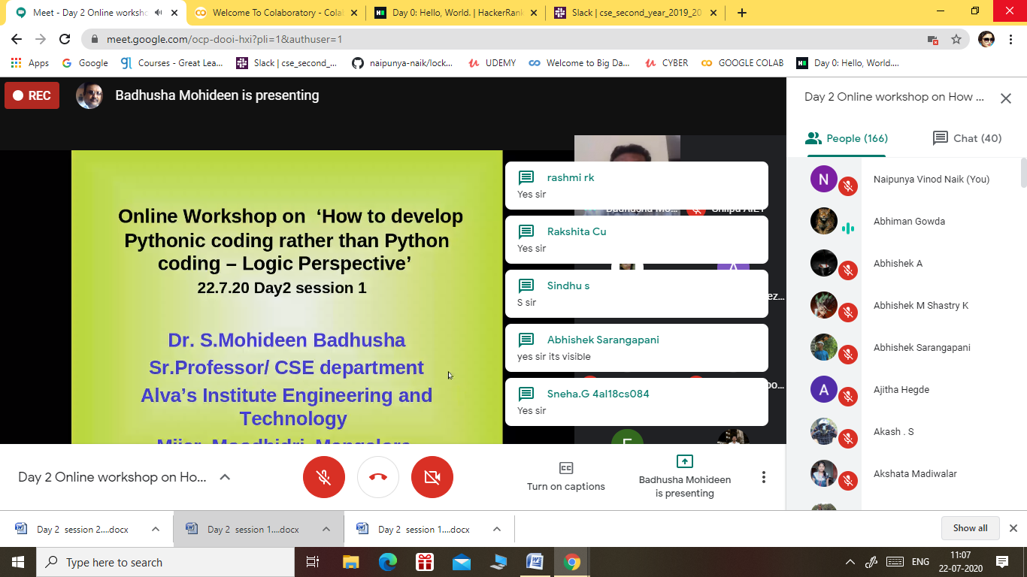
* 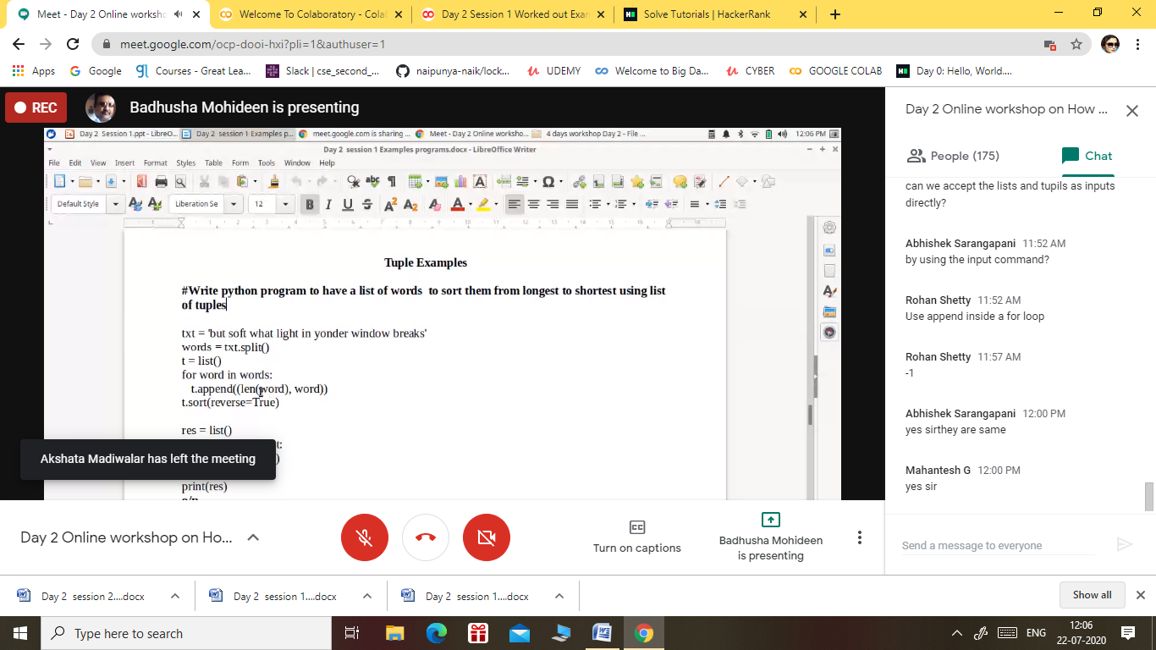

1. CERTIFICATION COURSE NAME:- **WHAT IS DATA SCIENCE?**

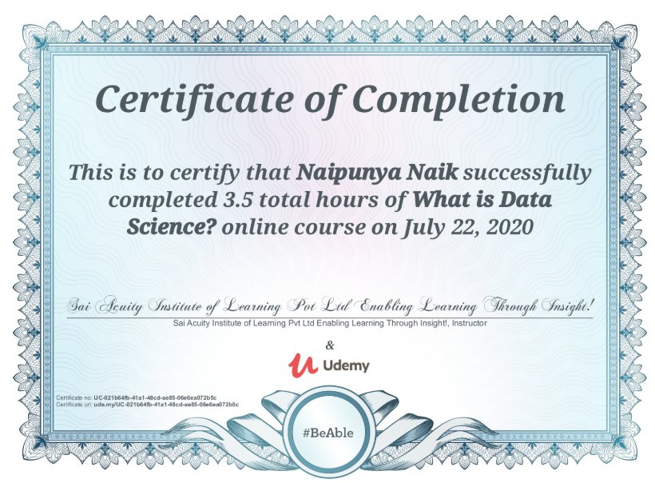

1. CERTIFICATION COURSE NAME:- **GOOGLE CLOUD PLATFORM BIG DATA AND MACHINE LEARNING FUNDAMENTALS**

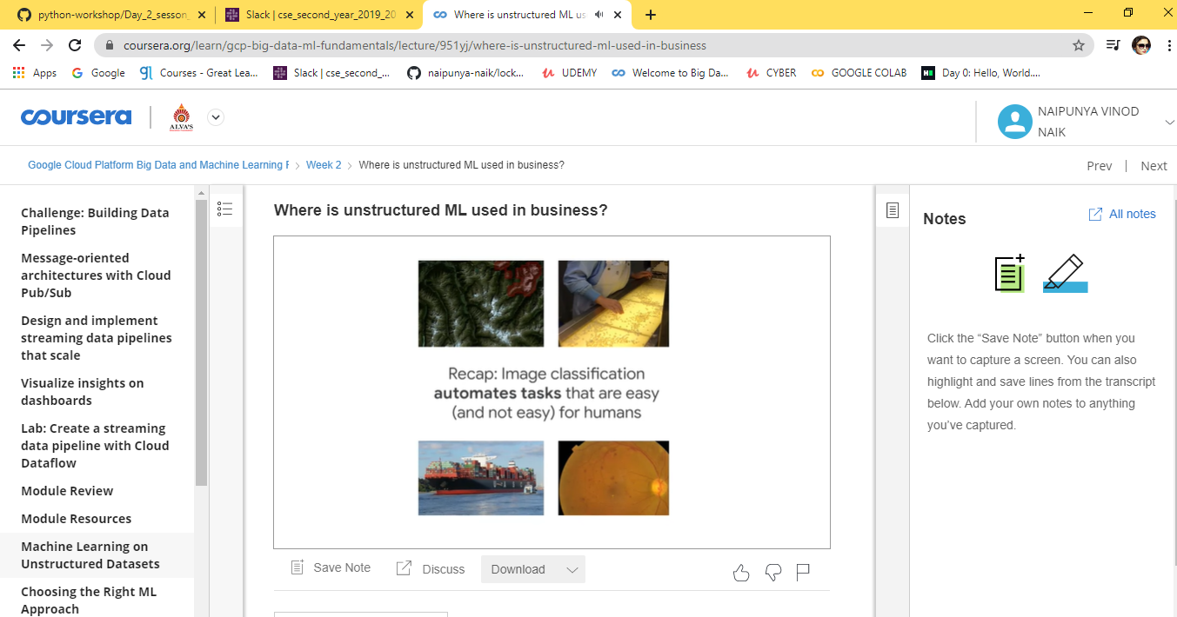

Coding Challenges Details: (Attach the snapshot and briefly write the report for the same).

PROBLEM STATEMENT:- TODAY I ATTEMPTED A HACKER RANK 30-DAYS OF CODE CHALLENGE .

**Task**  
To complete this challenge, you must save a line of input from stdin to a variable, print Hello, World. on a single line, and finally print the value of your variable on a second line.

You've got this!

**Note:** The instructions are Java-based, but we support submissions in many popular languages. You can switch languages using the drop-down menu above your editor,input string and the  variable may be written differently depending on the best-practice conventions of your submission language.

**Input Format**

A single line of text denoting  input string (the variable whose contents must be printed).

**Output Format**

Print Hello, World. on the first line, and the contents of inputstring on the second line.

**Sample Input**

Welcome to 30 Days of Code!

**Sample Output**

Hello, World.

Welcome to 30 Days of Code!

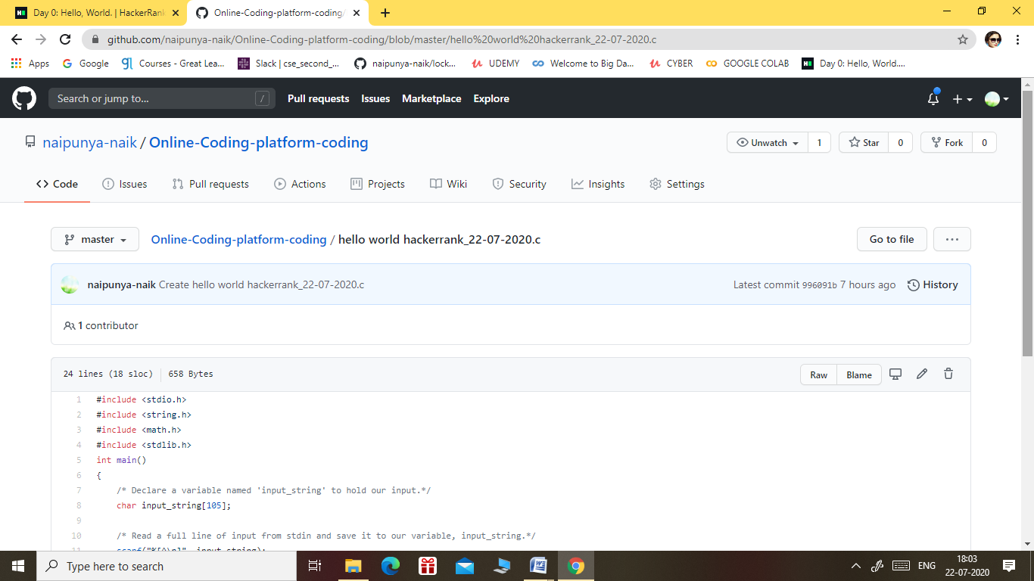

GITHUB REPOSITORY LINK:-

<https://github.com/naipunya-naik/Online-Coding-platform-coding/blob/master/hello%20world%20hackerrank_22-07-2020.c>